**Task#1   
What is the orchestration technology?**

Orchestration in a DevOps environment typically involves procedural or script-based tools (these advantage of these tools being easily derived from manual processes, focus on the process), which are a simple set of commands used to deploy and connect an application.[1]

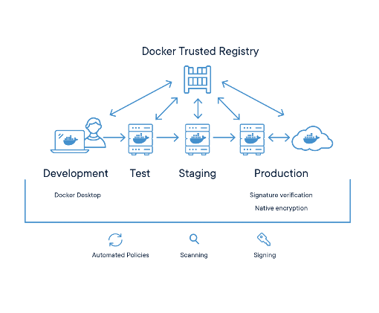

**What is Kubernetes?**

Kubernetes is an open-source container management tool hosted by Cloud Native Computing Foundation (CNCF) developed to manage both long-running processes and batch jobs, which was earlier handled by separate systems.

* comes with the capability of automating deployment, scaling of application, and operations of application containers across clusters. It is capable of creating a container-centric infrastructure.

**Task#2**   
  
**1. Compare between Kubernetes Master node & Kubernetes Worker node.**

Each Node is managed by the Master, it has multiple pods and it automatically handles scheduling the pods across the Nodes in the cluster. The Master's automatic scheduling takes into account the available resources on each Node….**Every Kubernetes Node runs at least:**

* Kubelet: a process responsible for communication between the Kubernetes Master and the Node; it manages the Pods and the containers running on a machine.
* A container runtime (like Docker) is responsible for pulling the container image from a registry, unpacking the container, and running the application.

Containers should only be scheduled together in a single Pod if they are tightly coupled and need to share resources such as a disk.

**2. Setup a single node cluster ( use Minikube)**

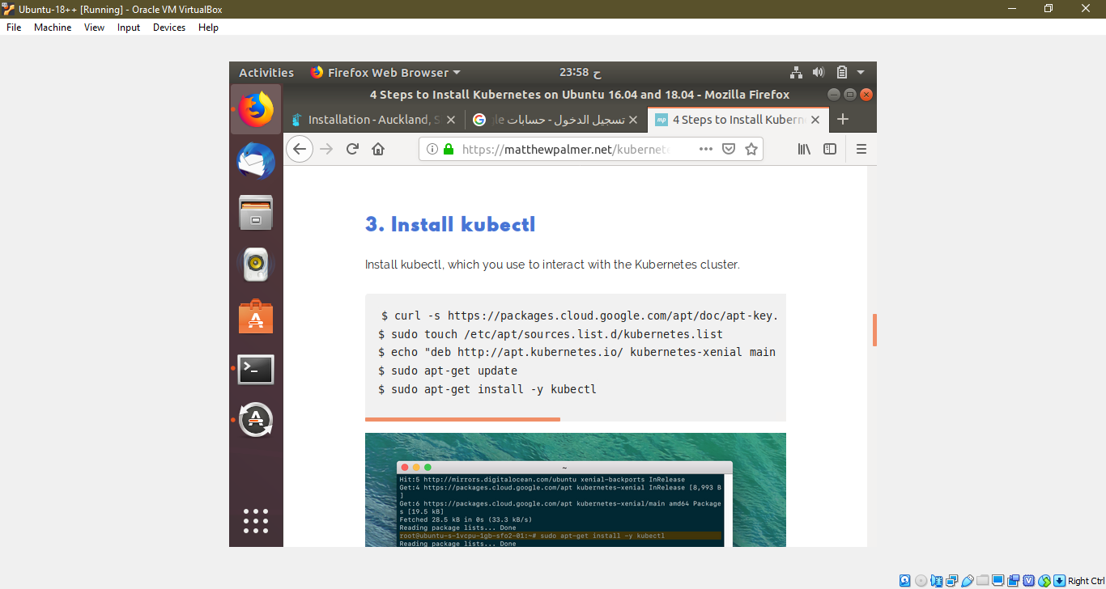

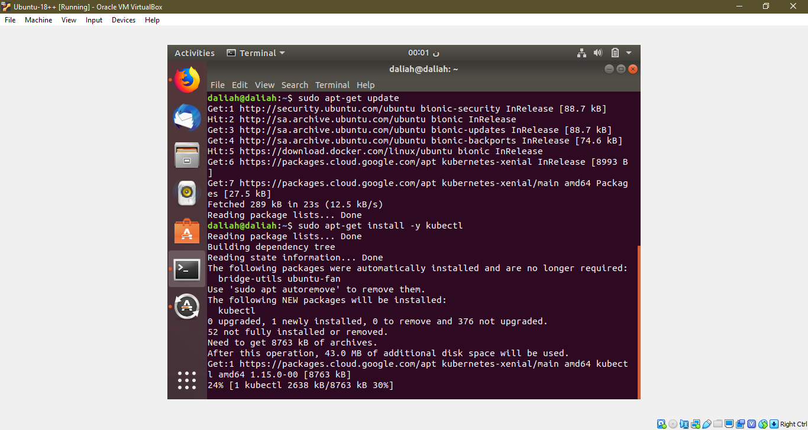

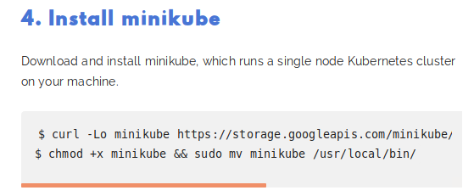

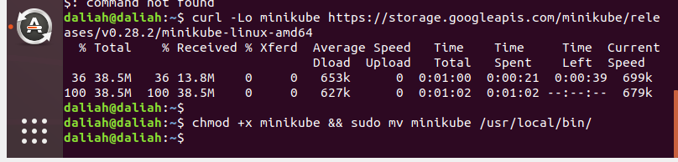

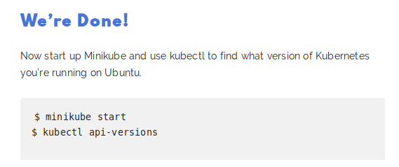

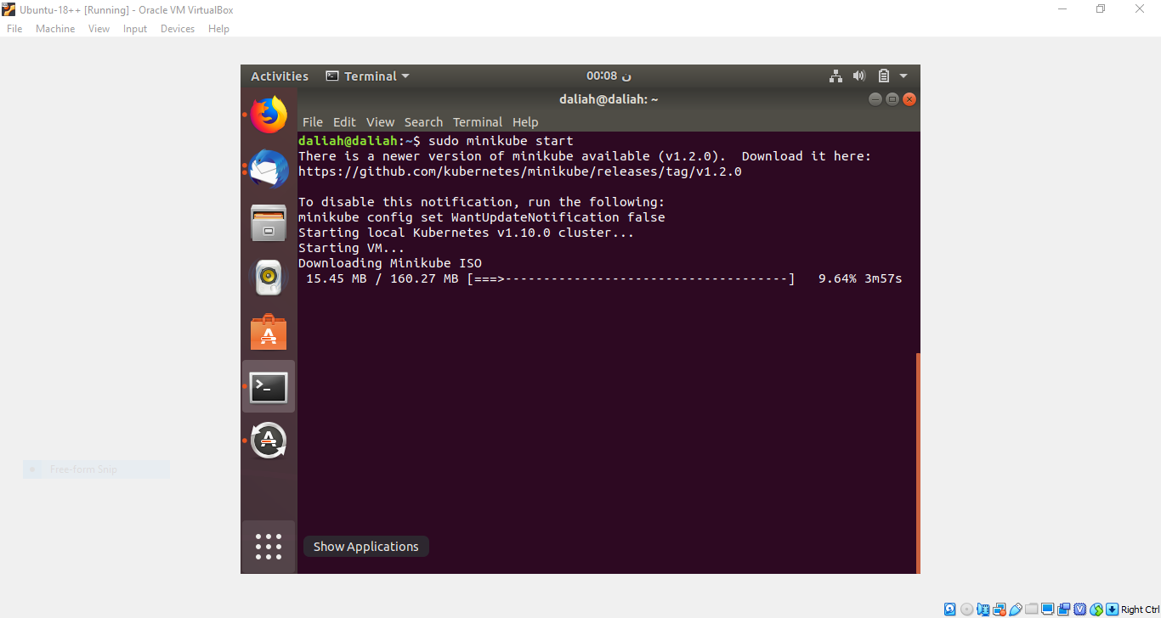

**\*\*\*\*\*\***

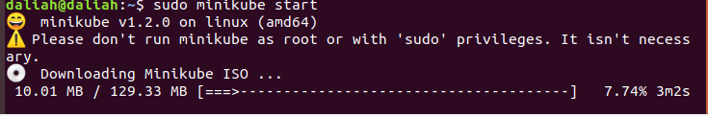

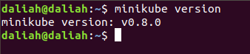

**\*\*\*\*\*\*\*\*\*\*\*\*\*\*\*\*\*\*\*\*\*\*\*\*\*\***

**Bounce Task:**   
 **Go to** [**https://www.katacoda.com/courses/kubernetes**](https://www.katacoda.com/courses/kubernetes) **, and try to solve kuberenets scenarios to ge deeper with it ( at least 3 scenarios) .  
  
-------------------------------------------------------**

[1]J. Damania and J. Damania, "Automation vs Orchestration in an Effective DevOps Culture - The Official Rackspace Blog", *The Official Rackspace Blog*, 2019. [Online]. Available: https://blog.rackspace.com/automation-vs-orchestration-in-an-effective-devops-culture. [Accessed: 14- Jul- 2019].

[2]"Kubernetes Quick Guide", *www.tutorialspoint.com*, 2019. [Online]. Available: https://www.tutorialspoint.com/kubernetes/kubernetes_quick_guide.htm. [Accessed: 14- Jul- 2019].